In the backend DB, we will make N and then give yes to suitable people

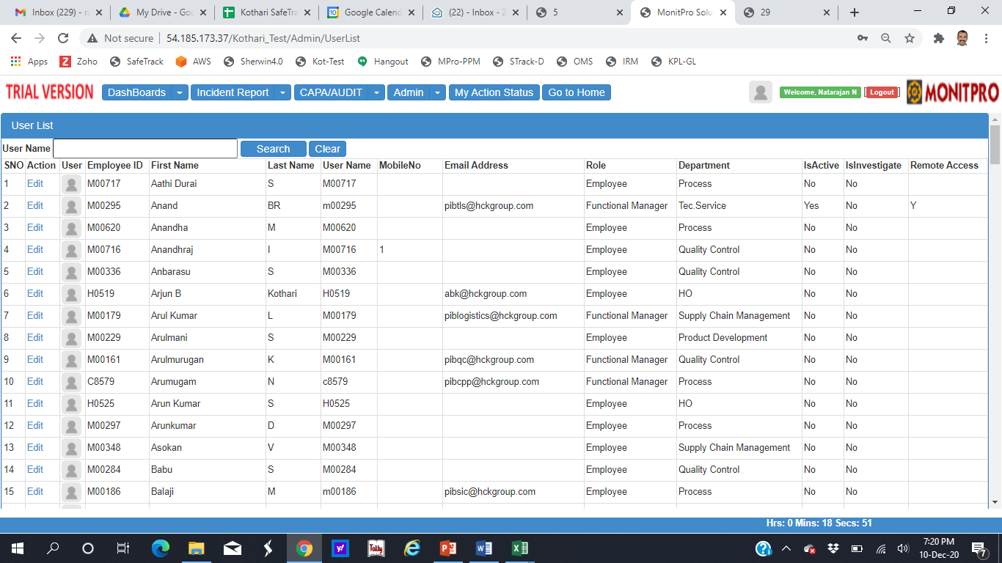

Show Serial number in the Equipment list. Also Name shall be changed to Equipment List

